**DAILY ONLINE ACTIVITIES SUMMARY**

|  |  |  |  |  |  |
| --- | --- | --- | --- | --- | --- |
| **Date:** | **30 may 2020** | | **Name:** | **KHATHEEJA SAFREENA** | |
| **Sem & Sec** | **4th sem, 2nd year** | | **USN:** | **4AL18CS037** | |
| **Online Test Summary** | | | | | |
| **Subject** | **DATA COMMUNICATION (18cs46)**  **COMPLEX ANALYSIS, PROBABILITY AND STATISTICAMETHODS (18mat41)** | | | | |
| **Max. Marks** | **DC-30**  **Maths-30** | **Score** | | **DC- 28**  **MATHS-30** | |
| **Certification Course Summary** | | | | | |
| **Course** | **1.INTRODUCTION TO DIGITAL MARKETING.**  **2.PYHON FOR MACHINE LEARNING.** | | | | |
| **Certificate Provider** | **Great Learning** | **Duration** | | | **2.5 hours.**  **10 hours.** |
| **Coding Challenges** | | | | | |
| **Problem Statement:1 program** | | | | | |
| **Status: Executed** | | | | | |
| **Uploaded the report in Github** | | **Yes** | | | |
| **If yes Repository name** | | **[http://github.com/shafreenasharief/lockdown-coding](http://github.com/shafreenasharief/lockdown-coding" \o "http://github.com/shafreenasharief/lockdown-coding)**  **[http://github.com/shafreenasharief/locked-down--certification-course](http://github.com/shafreenasharief/locked-down--certification-course" \o "http://github.com/shafreenasharief/locked-down--certification-course)**  **[http://github.com/shafreenasharief/Daily_Report](http://https://github.com/shafreenasharief/Daily_Report" \o "http://https://github.com/shafreenasharief/Daily_Report)** | | | |
| **Uploaded the report in slack** | | **Yes** | | | |

Online Test Details: (Attach the snapshot and briefly write the report for the same)

Certification Course Details: (Attach the snapshot and briefly write the report for the same)

Coding Challenges Details: (Attach the snapshot and briefly write the report for the same)

**ONLINE TEST SUMMARY**:

Today **DATA COMMUNICATION (18cs46)** was conducted of first module. Total marks for the test was 30.

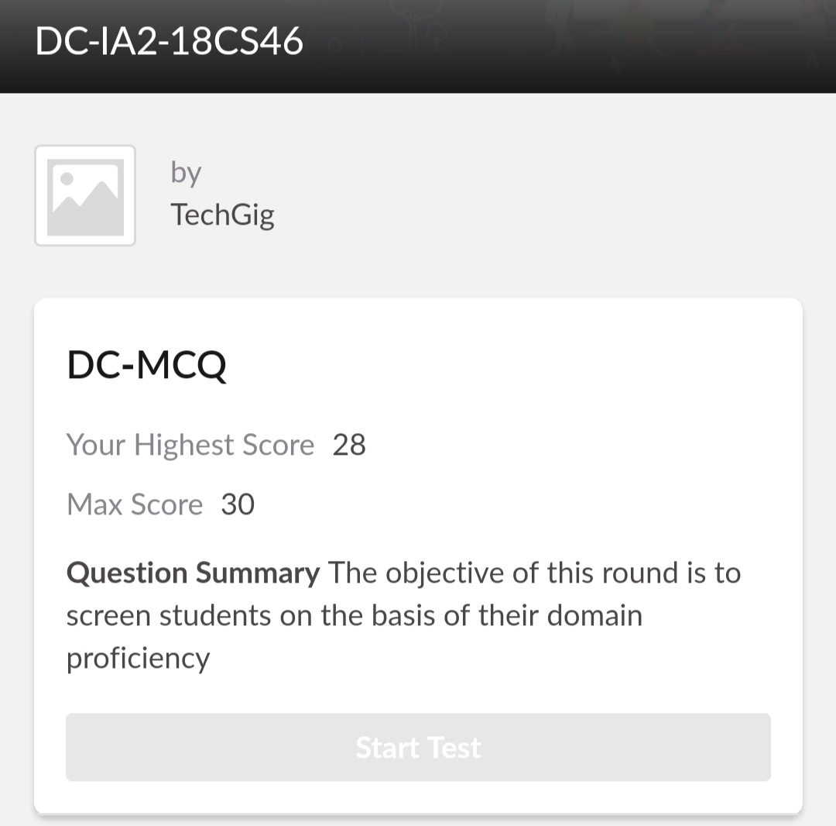

Today 18MAT41 also conducted for 30 marks which is divided into two parts 10 questions of 1 mark and 10 questions of 2 marks at 3:00 Pm.

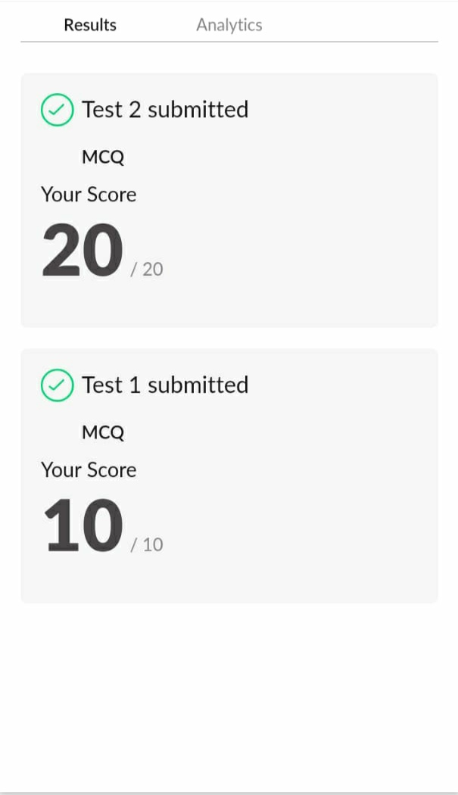

**ONLINE CERTIFICATION COURSE SUMMARY:**

**1. INTRODUCTION TO DIGITAL MARKETING.**

* I successfully completed certification course on INTRODUCTION TO DIGITAL MARKETING on great learning.The course is secluded for 2.5 hour.Today I completed all the module .I attempted quiz ,which gave me a clear veiw about the topics that were thought and discussed
* It consists of 10 modules including assessments.
* **The concept covered in the course are as follows:**
* Consumer journey of today.
* Explanation of new medias.
* Explanation of new medias-cont.
* Purpose of understanding the brand.
* Introduction to Facebook Marketing.
* Purpose of using Facebook as a marketing channel.
* Facebook interface and types of Audience.
* Adset setup guide.
* What is custom audience.
* Types of ads.

I completed the course and toke up quiz on digital marketing scoring 10 out of 10 and also secured certificate.



**2.MACHINE LEARNING WITH PYTHON.**

* Today I'm doing a course on MACHINE LEARNING WITH PYTHON. It is a 10 hours course. I completed 1 module. Which explains about introduction of python and it's Libraries. I attempted quiz which gave me a clear veiw about the topics that were thought and discussed.
* It consists of 30 modules including assessments.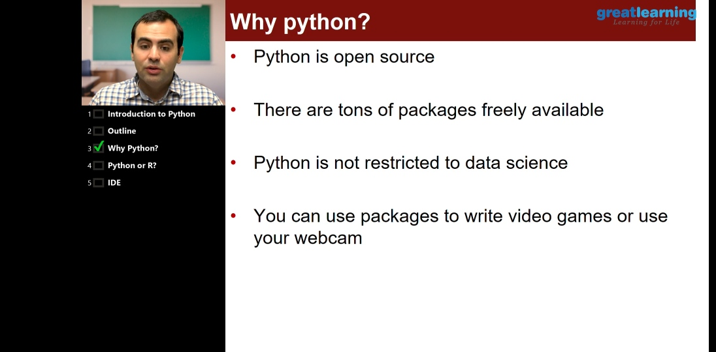

**ONLINE CODING CHALLENGE:**

Today I solved 1 coding challenge,

Write a C Program to count Uppercase, Lowercase, special character and numeric values for a given String.

SOLUTION : I have uploaded the solution of the above 4 coding problems in my GitHub repository.

[http://github.com/shafreenasharief/lockdown-coding](http://github.com/shafreenasharief/lockdown-coding" \o "http://github.com/shafreenasharief/lockdown-coding)

[http://github.com/shafreenasharief/locked-down--certification-course](http://github.com/shafreenasharief/locked-down--certification-course" \o "http://github.com/shafreenasharief/locked-down--certification-course)

[http://github.com/shafreenasharief/Daily_Report](http://github.com/shafreenasharief/Daily_Report" \o "http://github.com/shafreenasharief/Daily_Report)

